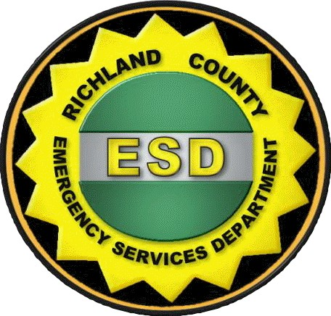
Hazardous Materials Certification Statement

Business Name:

Physical Address:

Business Type: Telephone Number:
(Initial only one)
_______ I acknowledge that my business DOES require, as defined in Richland County Ordinance (RCO) 13, a Hazardous Materials Permit. I hereby attest that all filing, permitting and planning required under RCO 13, will be completed within thirty (30) days of this date. Applications may be obtained via e-mail request to HazMat@RichlandCountysc.gov

_______ I certify that this business DOES NOT, at any time, produce, use, store, handle, dispense or in any manner have on its property(ies) material which meet the definition(s) of Hazardous Materials, Hazardous Waste or Hazardous Substances as defined within the currently adopted Fire Code and/or as defined by the current edition(s) of 40 CFR, 49 CFR or CERCLA 101 (14) or material which may react to cause or perpetuate fires, explosions or dangerous reactions, or which by their presence create or augment a fire or explosion hazard, or which because of toxicity, flammability, or liability of fire, explosion or reaction render fire fighting, rescue or public safety operations abnormally dangerous or difficult, or create a threat to public health, safety or the environment, in quantities at or above the threshold requiring permitting, as defined in Richland County Ordinance (RCO) 13.

Any person who falsely certifies to the above statement(s) shall be guilty of Perjury under the South Carolina Code of Laws. Additionally, any person failing to register material(s) or pay registration / renewal fee(s) covered by RCO 13, is in violation of the ordinance and shall be guilty of a misdemeanor. Each day a violation exists shall be a separate violation(s).

Please return this form, signed and notarized, to :
Richland County Hazardous Materials, 1410 Laurens Street, Columbia, SC 29204

(Declaration must be signed by an Officer of the company, authorized to legally bind the company. This Declaration shall be witnessed and attested to by the signature and seal of a current Notary Public.)
------------------------------------------------------------------------------------------------------------------------------
Under penalty of perjury, I declare that all information provided as part of this Hazardous Materials Certification Statement is true and correct.

Print Name: Title:

Signature: Date:
-----------------------------------------------------------------------------------------------------------------------------------
SWORN TO AND SUBSCRIBED BEFORE ME THIS DAY OF , 20

(Printed Name)
NOTARY PUBLIC FOR Seal

MY COMMISSION EXPIRES:
(Signature)

gfm/gfm/gfm 09-05-24

